DEVELOP A WEB APPLICATION USING NODE-RED

|  |  |
| --- | --- |
| Date | 01 November 2022 |
| Team ID | PNT2022TMID14744 |
| Project Name | Project-Real-time River  Water Quality Monitoring and Control System |
| Maximum Marks | 4 Marks |

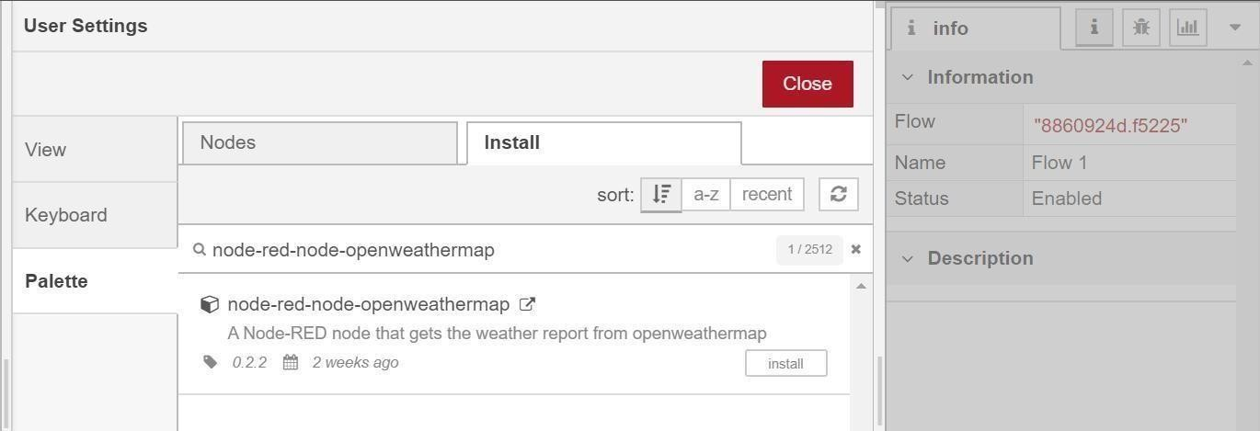

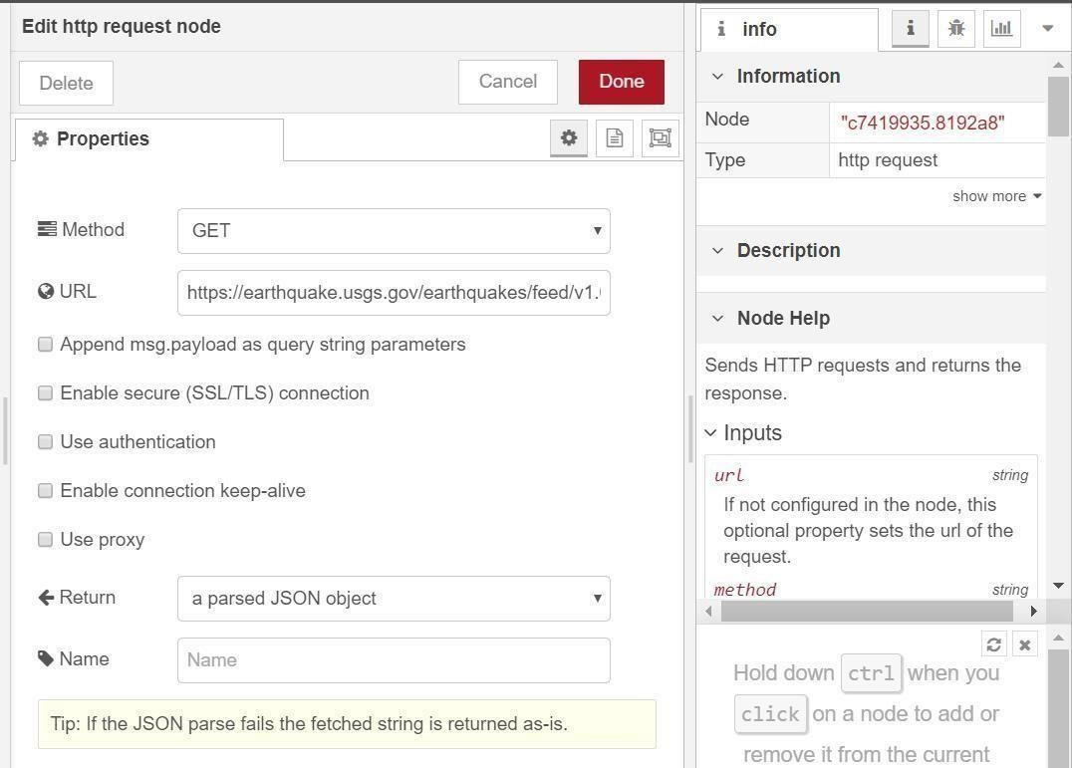

Add a **change** node. Double-click the node to modify it. Name this node Set Earthquake Info. In

the **Rules** section, addes

rul to *Delete* msg.topic,

msg.headers, msg.statusCode, msg.responseUrl and

msg.redirectLis

t and

*Set*d payload.features.

msg.payloa

{

"type":properties.type, "magnitude": properties.mag, "location": properties.place,

"longitude":geometry.coordinates[0], "latitude":geometry.coordinates[1], "depth":geometry.coordinates[2], "timestamp": $fromMillis( properties.time,